
DetactX

Graduation Project

DEPI Round 3 Microsoft Machine Learning Track

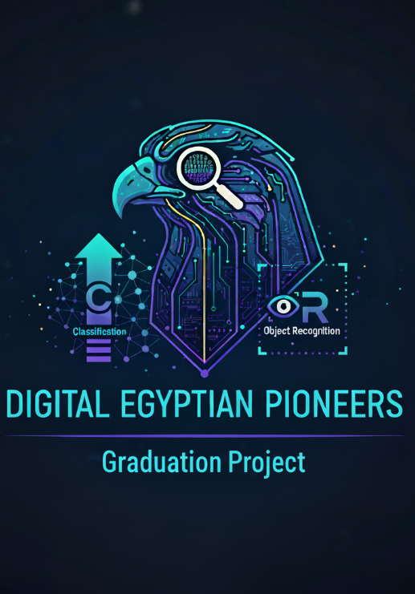
Submitted By:
- Basel Mohamed Mostafa
- Omar Yasser Sayed
- Zeyad Gamal Mohamed
- Abdelrahman Kamal Elkhabery
- Mohamed Hamada Farghali
- Ziad Ahmed Samir

Project Abstract:
- Car Classification & Object Recognition website.

Internship Program:
Microsoft Machine Learning Engineer
11/30/2025

